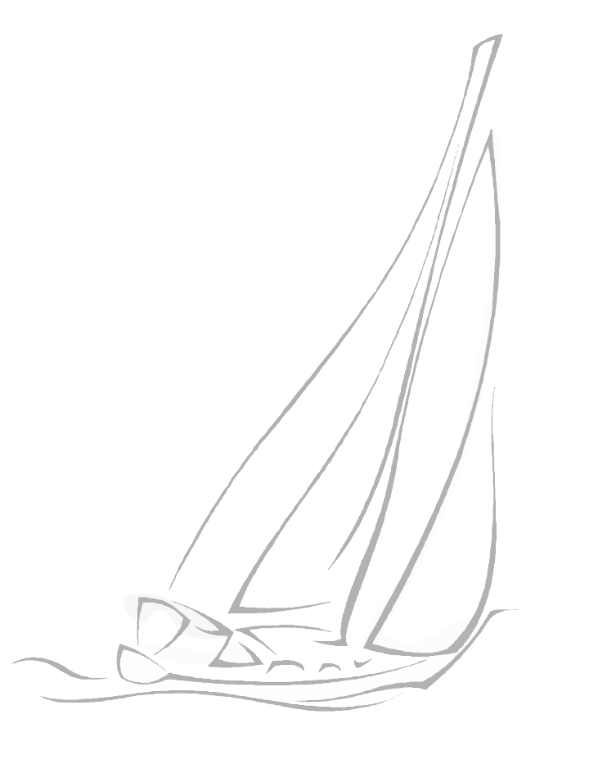

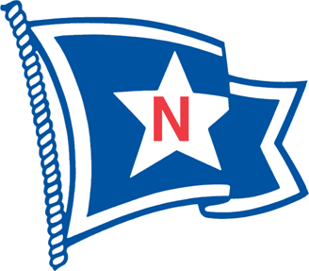

Attention North Star Sailors:

A special invitation to North Star Sail Club from DRYA.

Dear DRYA Club Members, Regatta Chairmen, and Commodores:

After months of planning we are pleased to announce the arrival of the "DRYA Performance Series", a new regatta series designed to give easy access to high-performance racing to any DRYA sailor, and to encourage participation between DRYA member clubs.

The format is simple.  Fast, fun, and exciting high-performance racing in front of Bayview Yacht Club in their club-fleet of Ultimate-20's.  Up to 20 teams can participate in these Individual single-day regattas over the summer.  Each registered DRYA member club is guaranteed 1-2 spots, with the remaining spots available on a first come-first serve basis.

There is tremendous demand in our area for this type of high-performance racing in addition to the great DRYA schedule that is already in place.  We see this as an enhancement to our sailing community which will allow members to broaden their sailing exposure, something that will certainly create excitement on the lake and should encourage further participation in our sport.  We ask that you join us in helping to spread the word within your own club.

The initial Pilot Series, the inaugural test event, takes place on May 13th.  A great tune-up for the Bayview One Design regatta!!  Included in this email is all the necessary information regarding the event.  To make this initial event a success we kindly ask you to help us with two things: please print and post the flyers somewhere at your club to help spread the word; and please contact a handful of sailors within your membership that you think might be interested in participating.

Thank you for your help with this!  We look forward to having each DRYA club represented at the Pilot Event in May!!!

Ian Hollerbach

DRYA Sport Boat Initiatives

The North Star Race Committee is actively working to put together two or more teams to represent North Star Sail Club and compete in this series. It is in the blood of our sail club to compete in sailing venues of this type. We are presented with a unique opportunity to show our competitive spirit.

The race committee is asking those North Star sailors to submit their name, email address and phone number to the race committee so that we can compile a list of eligible sailors. We want to have two or more teams in place to submit to DRYA on Saturday April 1st. If you are interested, please send your information to Tony Schornak – [tlschornak@wowway.com](mailto:tlschornak@wowway.com). Tony will compile the list. Please designate if you want to crew or skipper a boat for this event. We have attached the DRYA flyer and Notice of Race for your review. This is all preliminary now and we will do our best to accommodate our members and to keep you appraised of this regatta as it develops.

North Star Race Committee

32041 South River Road

Harrison Township, MI 48045

586-463-2192

www.northstarsail.org